Art, Writing & Reading Contests
2026 Summer Youth Tennis Program
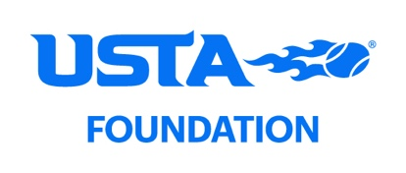

The Houston Parks and Recreation Department and Houston Tennis Association NJTL are joining together to offer
the following contests open to participants in the summer youth tennis programs.

Art Contest: Category 1: Tennis Ball Self-Portrait Category 2: Tennis Poster
Age Divisions: 4-6 years, 7-10 years, 11-13 years, 14-18 years Awards: Top 3 in each category in each age division
Rules:
- One art entry per student, either in Category 1 or Category 2.
- Entry must have name of child, age, park site, and phone number attached to art (use form below).
- The tennis ball self-portrait centers around decorating one tennis ball in whatever manner so as to resemble the student or a person they admire. Yarn, paint, glitter, paper, pens, etc. are all good sources of material. Children can request a tennis ball from the instructor at their park site if they need one.
- The poster should be related to tennis or NJTL. Children under the age of 7 may use an 8 ½” x 11” piece of paper if preferred.
- Entries should be submitted with the completed entry form. Students may give entry to their tennis instructor on July 16 or to the HTA Office, 3535 Briarpark Dr, Suite 250, Houston 77042, by the July 17 deadline.
- Entries will be displayed at the NJTL Kids Day on Friday, July 24 along with award recognition.

Writing Contest: Category 1: Poem Category 2: Research Report
Age Divisions: 7-10 years, 11-13 years, and 14-18 years Awards: Top 3 in each category in each age division
Rules:
- One writing entry per student per category.
- Entry must have name of child, age, park site and phone number (use form below).
- The poem should be at least 25 words and no more than 200, about tennis or related to NJTL.
- The report should be at least one page and no more than three pages. We encourage students to choose a pro player currently on the tour. Find out what country the player is from, give a brief introduction about the player, and then give some facts about their home country or their home city if selecting a player from the United States.
- Entries are due to the tennis instructor by July 16 or to the HTA Office, 3535 Briarpark Dr., Suite 250, Houston 77042 or emailed to hta.njtl.ace@gmail.com by July 17 with Writing Contest in the subject line.
- Entries will be displayed at the NJTL Kids Day on Friday, July 24 along with award recognition.

Additional Opportunities – Students are encouraged to participate in additional educational activities including:
NJTL Reading Rally, ACE Summer Circle, and Reading Corner for Young Aces to be held at several tennis sites, and Winward Academy (online college prep course for Grades 7 & up). Please contact Madonna Medina at hta.njtl.ace@gmail.com for handouts or more information.

Thank you for participating in our program this summer! Detach and submit entry form with completed project(s).
Name:______________________________________________________  Park/Community Center: _______________________________________ | Age: _________ |  | Contest: R  o Art-Tennis Ball  o Art-Poster  o Writing-Poetry  o Writing-Report | Age Division: R  o Ages 4-6  o Ages 7-10  o Ages 11-13  o Ages 14-18
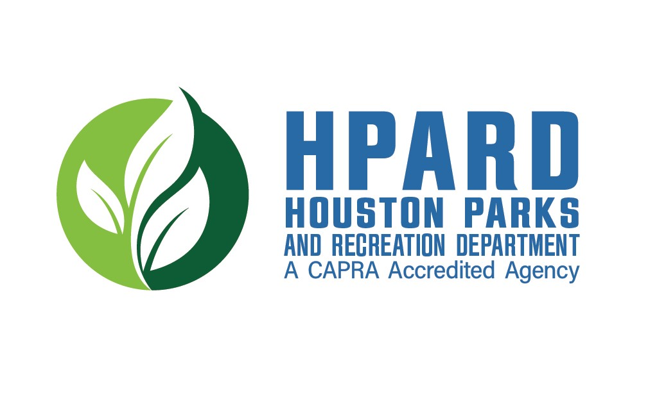
Email:
:

Phone:___________________________________

Coach:

Houston Tennis Association

3535
Briarpark Dr
ive, Suite 250

Houston, TX 77042
281
-
580
-
8313

(
Completed form must be attached to each entry.
)

