Reading Rally Student Log
Date Number of Pages Read__________

Reading Material

Date Number of Pages Read__________

Reading Material

Date Number of Pages Read__________

Reading Material

Date Number of Pages Read__________

Reading Material

Date Number of Pages Read__________

Reading Material
Please use notebook paper for additional reading logs with your name at the top. Do not list entire books; do list the total pages read. For this or other educational forms as pdfs, email hta.njtl.ace@gmail.com.
Total Pages Read __________
Reading Verified by
(Adult Signature)
Completed reading forms due by 5 p.m. on July 16. Scan and email (hta.njtl.ace@gmail.com) or turn in at the HTA office.
Houston Tennis Association
3535 Briarpark Drive, Suite 250
Houston TX 77042
281-580-8313

NJTL Reading Rally Summer 2026
“Taking Reading to the Tennis Courts”

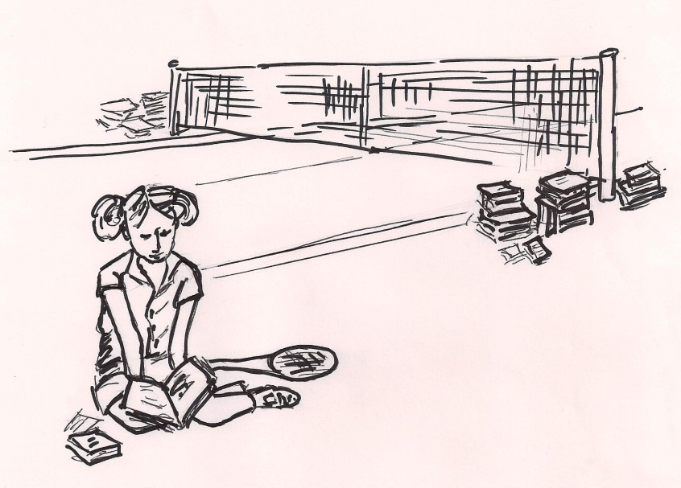

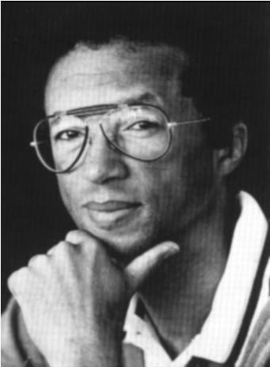
“For every hour spent on the playing field, two should be spent with a book.”
– Arthur Ashe - 1943-1993
National Junior Tennis & Learning
Co-founder

Rally: ral-ly (noun) a series of strokes interchanged between players (as in tennis) before a point is won; (verb) to come together again to renew an effort, to join in a common cause

About the Reading Rally Program

- The Reading Rally Program is open to students enrolled in the summer youth
tennis program or on waiting list
- Students will keep a log of their reading using the Rally form
- Starting June 15, each time you take time to read at least 10 pages in a book, magazine, newspaper or other printed material, enter the number of pages you read in the log

- You must have at least 5 entries on the Student Log to turn in the completed form

- Reading is fun and important. Take your time but read often. You never know what you might learn!
- Students submitting completed
Reading Rally forms by July 16
will be recognized at the 2026 NJTL Kids’ Day on July 24

- Please write legibly on entry form

- Scan completed reading logs and email to hta.njtl.ace@gmail.com

- After the Rally is over, we encourage
all students to continue reading



HTA NJTL
2026 Reading Rally Entry Form

Student Name
Park/Site Name
Gender (circle one) M F Date of Birth
Address
City________________________ State__________ Zip
Phone______________________________ Grade__________
Email
School Name
Ethnicity (circle one)
African American/Black Asian/Pacific Islander
Hispanic/Latino White/Caucasian Native American Other
Age Group (circle one) Girls 4 – 6 7 – 10 11 – 18
Boys 4 – 6 7 – 10 11 – 18

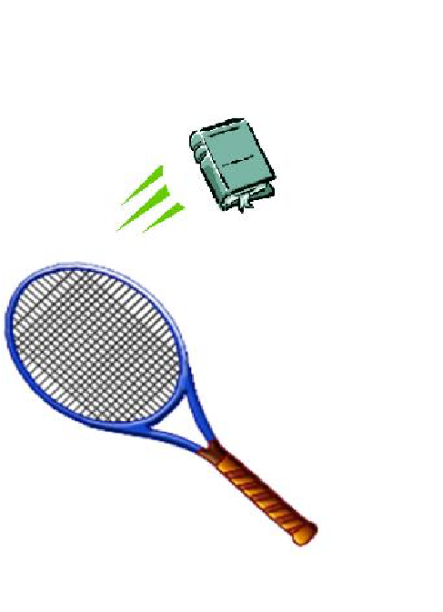
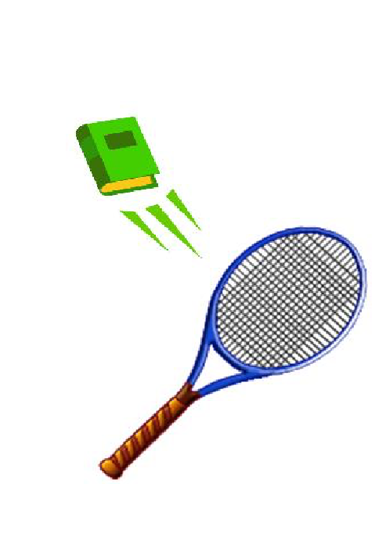
Parent/Guardian Signature



